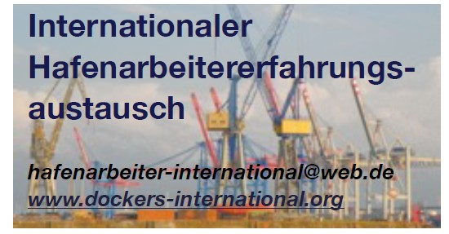
Coordination group for the international exchange of dockworkers’ experiences in the field of

Coordination group for the international exchange of dockworkers’ experiences

Rotterdam/Hamburg, 23 March 2026
Statement by the International Dockworkers’ Exchange of Experiences (IHAE)

Dockworkers stand up for peace
Since 28 February, the imperialist countries of the USA and Israel have been waging a war of aggression against Iran in violation of international law. This war is being waged for raw materials, political influence and geopolitical domination. Through this open war, the USA and Israel seek to assert and expand their influence in the Middle East, including against China and Russia.
In violation of international law and through fascist warfare, the outbreak of a Third World War is very much a calculated risk. The overthrow of the Islamic-fascist mullah regime in Iran has the sole aim of installing a US-aligned government – not the freedom of the people. The removal of the fascist regime in Iran must be the task of the Iranian people.
Ukraine, Gaza, Sudan, Iran … all these are predatory wars waged at the expense of workers, women and children. Dockers and seafarers must not allow this! WE SAY NO to war, genocide and imperialist aggression by the USA, Israel, NATO and the EU.
The Strait of Hormuz is a minefield. Shipowners, the EU and the waging imperialists bear criminal responsibility for the fact that ships have now been stuck in the hell of war for three weeks, so that the shipowners can continue to rake in huge profits. The number of injured and killed seafarers is rising daily!
We say no to the war economy and the transformation of ports into military hubs – everywhere! Dockworkers work to ensure the supply, logistics and transport of food, raw materials and industrial goods to the people – not for the machinery of war!
WE SAY YES to stepping up the fight for better wages, better working conditions, effective health and safety measures, and pensions sufficient for a dignified life – but also for workers’ rights such as the right to strike and the right to organise!
We need a thorough discussion within our trade unions about rejecting and fighting this war course. Grassroots trade unions such as USB and SI Cobas in Italy, PENEN in Greece, and Maurizio Landini, the president of the CGIL trade union, demand:
An immediate ceasefire!
Respect for international law and an end to the war!
And we add to this:
Immediate withdrawal of all naval vessels from the Strait of Hormuz.
The immediate establishment of a no-go zone for merchant ships.
We express our solidarity with all peoples who are victims of imperialist aggression. 6 February, as a joint day of action by dockers and seafarers under the slogan ‘No to War’, was a good start in at least five countries and 21 ports. Now we need a new day of action for world peace.
The International Dockworkers’ Exchange of Experience – IHAE – has been active since 2008. We provide information and organise solidarity with strikes and protests by dockworkers and seafarers all over the world. We strengthen our trade unions for the struggle, contribute our experiences and work together respectfully and as equals. We have organised visits to dockworkers and seafarers in Europe. Our aim is to contribute to the coordination of the struggles of dockers, seafarers and shipyard workers. We have a joint coordination group with strong links to ports in the Netherlands (Rotterdam), Italy (Naples), Germany (Hamburg, Rostock, Bremerhaven) and Greece (Piraeus). We operate according to democratic principles. We have added new issues to our agenda, such as the struggle to protect the natural environment, the fight against militarisation, fascism and predatory, imperialist wars.

