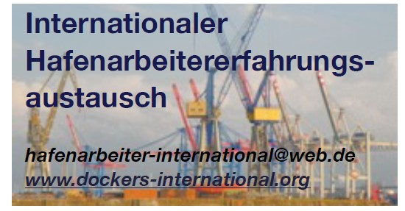
Coordination group for the international exchange of dockworkers’ experiences in the field of

Coordination group for the international exchange of dockworkers’ experiences
Rotterdam/Hamburg, 22 March 2026
…………………………………………………………………………………
The war against Iran, which violates international law, continues. The situation in the Strait of Hormuz and throughout the Persian Gulf is deteriorating daily, and attacks on merchant ships in the region are increasing, as is the number of seafarers killed and injured in the war being waged by US and Israeli imperialism against Iran.
Shipowners and the EU government bear criminal responsibility for the fact that ships have been trapped in the hell of war for 17 days, so that the shipowners can rake in huge profits. The Strait of Hormuz is a minefield. The seafarers on board the ships are in constant mortal danger.

The shipowners continue to trade on the lives of the seafarers in order to secure ‘good freight rates’, and demand that the crews sail ‘voluntarily’ through war zones. They are attempting to blackmail the seafarers into signing a statement that they are sailing voluntarily. They are offering an extra €1,600 in wages and, in the event of death, a further €9,000 for the families concerned. This is unscrupulous and inhumane!

No sacrifices for their profits!

The unions’ demands continue to be ignored. We stand in solidarity with the seafarers and their justified demands.
An immediate end to the war waged by US and Israeli imperialism against Iran.

Immediate withdrawal of all seafarers from the Strait of Hormuz
at the shipowners’ expense.
Immediate establishment of a no-go zone for merchant ships.

PENEN – the Greek Seafarers’ Union – proposes a 48-hour blockade (strike) for all Greek and Greek-owned seagoing vessels calling at Greek ports.

International Coordination Group of the

International Harbours and Dockers’ Exchange (IHAE)

